Project Documentation

# Introduction

**Project Title:** Fitflex:your personal fitness companion

**Team Leader:** Bhuvaneswari A

[bhuvaneswarivel376@gmail.com](mailto:bhuvaneswarivel376@gmail.com)

**Team Members : **Priyadharshini R

[ravidharshini67@gmail.com](mailto:ravidharshini67@gmail.com)

Maheshwari N

[maheshwarin5154@gmail.com](mailto:maheshwarin5154@gmail.com)

Nithyasri S

[sivanithyasri2007@gmail.com](mailto:sivanithyasri2007@gmail.com)

Lavanya P

[lavanyarasammal@gmail.com](mailto:lavanyarasammal@gmail.com)

**Project Overview**

Welcome to the forefront of fitness exploration with SB Fitzz! Our innovative fitness app is meticulously designed to revolutionize the way you engage with exercise routines, catering to the diverse interests of both fitness enthusiasts and seasoned workout professionals. With a focus on an intuitive user interface and a comprehensive feature set, SB Fitzz is set to redefine the entire fitness discovery and exercise experience.

Crafted with a commitment to user-friendly aesthetics, SB Fitzz immerses users in an unparalleled fitness journey. Effortlessly navigate through a wide array of exercise categories with features like dynamic search, bringing you the latest and most effective workouts from the fitness world.

From those embarking on their fitness journey to seasoned workout aficionados, SB Fitzz embraces a diverse audience, fostering a dynamic community united by a shared passion for a healthy lifestyle. Our vision is to reshape how users interact with fitness, presenting a platform that not only provides effective exercise routines but also encourages collaboration and sharing within the vibrant fitness community.

Embark on this fitness adventure with us, where innovation seamlessly intertwines with established exercise principles. Every tap within SB Fitzz propels you closer to a realm of diverse workouts and wellness perspectives. Join us and experience the evolution of fitness engagement, where each feature is meticulously crafted to offer a glimpse into the future of a healthier you.

Elevate your fitness exploration with SB Fitzz, where every exercise becomes a gateway to a world of wellness waiting to be discovered and embraced. Trust SB Fitzz to be your reliable companion on the journey to staying connected with a fit and active lifestyle.

Project Goals and Objectives:

The overarching aim of SB Fitzz is to offer an accessible platform tailored for individuals passionate about fitness, exercise, and holistic well-being.

Our key objectives are as follows:

User-Friendly Experience: Develop an intuitive interface that facilitates easy navigation, enabling users to effortlessly discover, save, and share their preferred workout routines.

Comprehensive Exercise Management: Provide robust features for organizing and managing exercise routines, incorporating advanced search options for a personalized fitness experience.

Technology Stack: Harness contemporary web development technologies, with a focus on React.js, to ensure an efficient and enjoyable user experience

**Architecture**

**Component Structure:**

- Pages folder – Contains files that act as pages for different routes.

- Components folder – Contains reusable UI components (e.g., Navbar, Hero, Search, Footer, Exercise details).

- Styles folder – Contains CSS files for styling.

**State Management:**

- State handled within components and via API responses

- Axios used for API data fetching

- (Future enhancement: can integrate Context API/Redux for global state)

**Routing:**

- Implemented with React Router DOM for navigation across pages (Home, Categories, Exercises).

# Setup Instructions

**Prerequisites:**

- Node.js and npm

- React.js

- Git for version control

- Code editor (VS Code, WebStorm, or Sublime)

**Installation:**

1. Clone or download the repository:  
 git clone <repo-link>  
 cd fitness-app-react

2. Install dependencies:  
 npm install

3. Start development server:  
 npm start

4. Access the app at http://localhost:3000

**Download Links:**

- Project Code: Google Drive Link

- Project Demo: Video Demo

# Folder Structure

- components/ – Navbar, Hero, Search, Footer, Exercise components

- pages/ – Category page, Exercise page, About page

- styles/ – About.Css,Exercise.Css

- assets/ – Images/icons

- utilities/ – Helper functions, Axios setup

# Running the Application

- Navigate to the project directory

- Run:  
 npm start

- Open http://localhost:3000 in browser

# Component Documentation

**Key Components:**

- Navbar – Navigation menu

- Hero – Landing page header section

- Search – Search bar with categories

- Category Page – Displays different exercise categories

- Exercise Page – Shows detailed workout info with related YouTube videos

**Reusable Components:**

- Buttons, Cards, and Search components

# State Management

**Global State:**

- Currently managed through React state and Axios API calls

- Data fetched from Fitness API & YouTube API

**Local State:**

- Handled inside components for search input, selected category, and exercise details

# User Interface

- Hero Section – App introduction

- Search Page – Explore exercises by category

- Category Page – Exercise listings

- Exercise Page – Detailed workout with instructions and related videos

# Styling

- Frameworks/Libraries: Bootstrap or Tailwind CSS

- Custom CSS: Stored in styles/ folder

- Icons: React Icons

# Testing

**Testing Strategy:**

- Unit testing (Jest + React Testing Library) for components

- Integration testing for API data fetching

- End-to-end testing (future scope)

**Code Coverage:**

- Jest coverage reports can be configured

# Screenshots or Demo

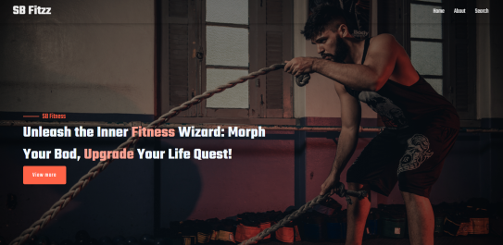

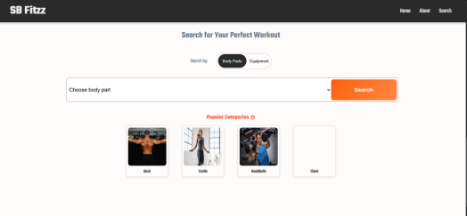

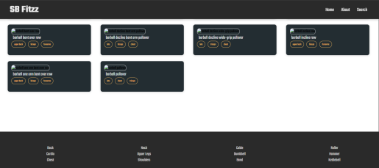

# Known Issues

- Limited state management (no Redux/Context yet)

- API dependency: if external APIs fail, exercises won’t load

- No authentication module yet

# Future Enhancements

- Add user authentication (login/signup)

- Personalized workout plans

- Progress tracking dashboard

- More animations and UI improvements

- Notifications and reminders for workouts